
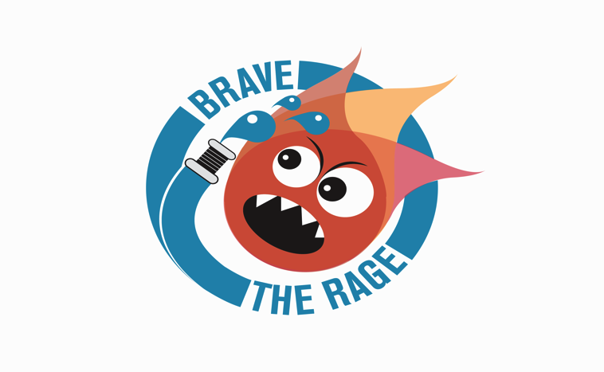

PETS CORNER- HARLOW
Tuesday 29TH November 2016: 6.30pm- 8.30pm
https://goo.gl/pBw0vz

Free Refreshments & Resource Pack Included
- Meal Time Madness?
- Temper Tantrums?
- Deliberate Defiance?
- Rude Reply’s?
- Withdrawn & Worried?
- Sulky Strops?

FREE PARENTS INFORMATION TRAINING WORKSHOP

FIND SOLUTIONS TO;

UNDERSTANDING CHALLENGING BEHAVIOUR ASSERTIVE & CONFIDENCE BUILDING TIPS

THE SIMPLE ‘5 STEP-BY- STEP’ ACTION PLAN SELF- IDENTITY, SELF-ESTEEM & RESPECT

PRACTICAL TOOLS & TECHNIQUES FRIENDSHIP AND RELATIONSHIP SKILLS

*Icebreakers, Role Plays, Movie Clips & Resources

Reception & Year One

‘Solutions to Stress & Anger’

PARENTS INFO SESSION

